
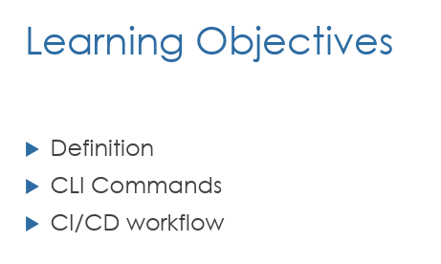
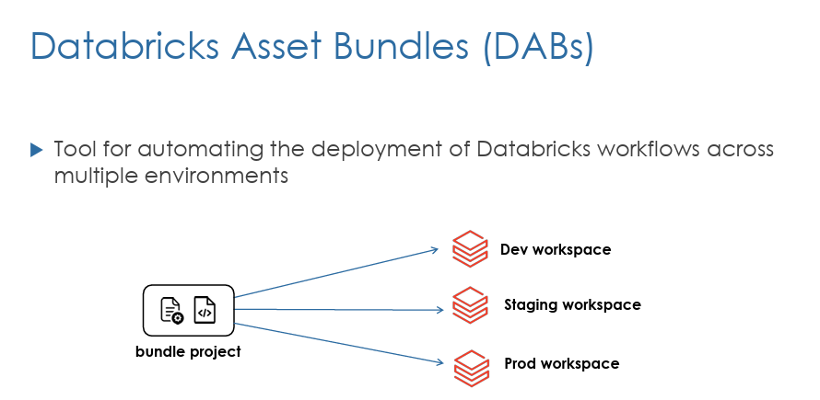
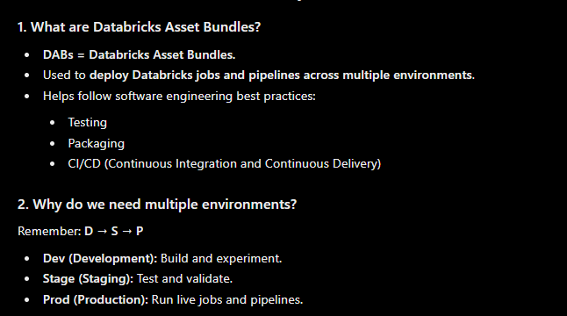
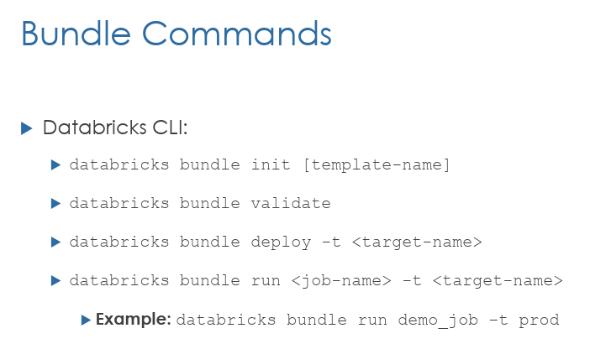
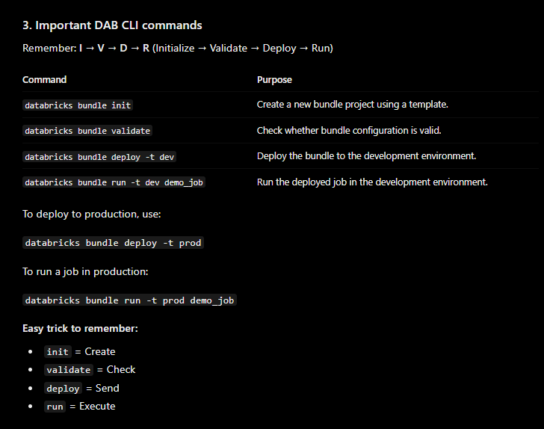
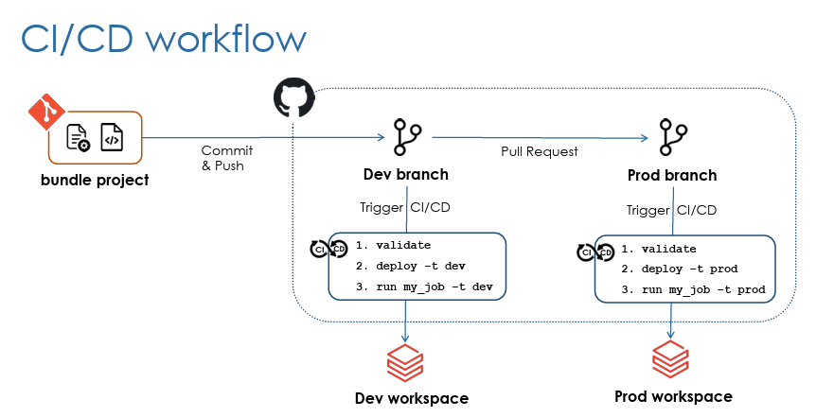
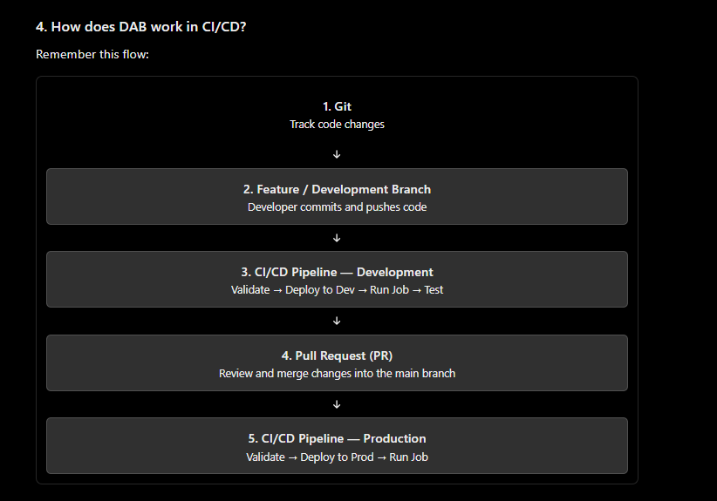
Databricks Asset Bundles are now called Declarative Automation Bundles
Install VS code
Add databricks extension
1.create new databricks project
2. url and oauth recommend
3. enter profile name “databricks teach”
4.auth by databricks login
5. databricks project new folder in the document
6. automatically running databricks bundle init
7.temple type default enter and automically assign python
8. project name bookstore
9.say yes for sample notebook
10 .say yes for sample etl pipline
11.say no for python wheel , because we not using our project
12. say yes for serverless compute, and next say yes
13. open the folder
14. databricks.yml main configuration file, this will contain project setting in yaml language

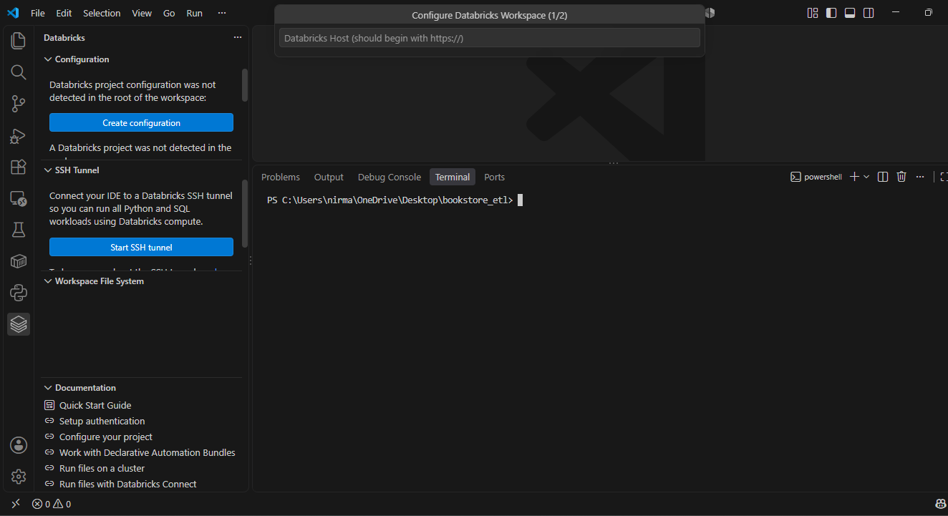
Step 1: install databricks CLI command
Step 2: Create configuration
Step 3: url need to paste
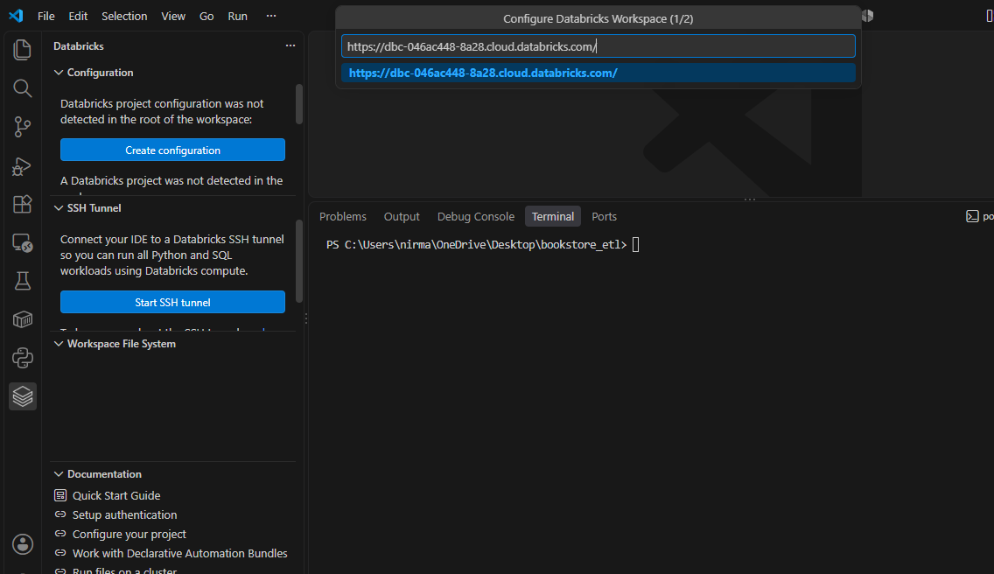
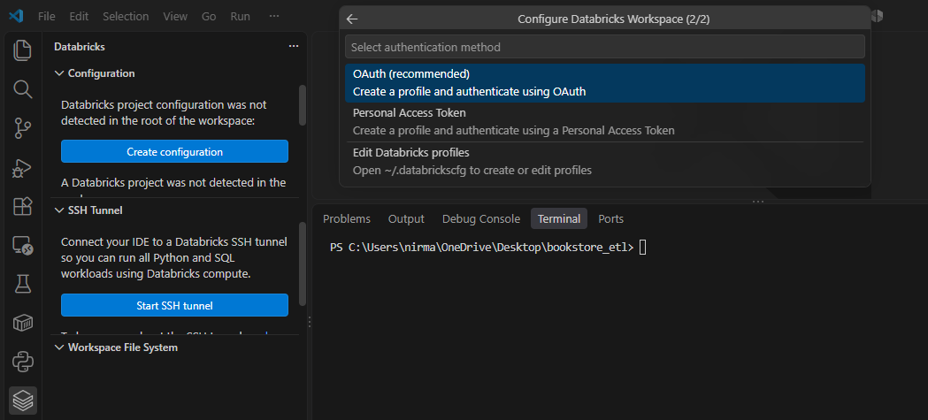
Step 4: Oauth default
Step 5: profilename
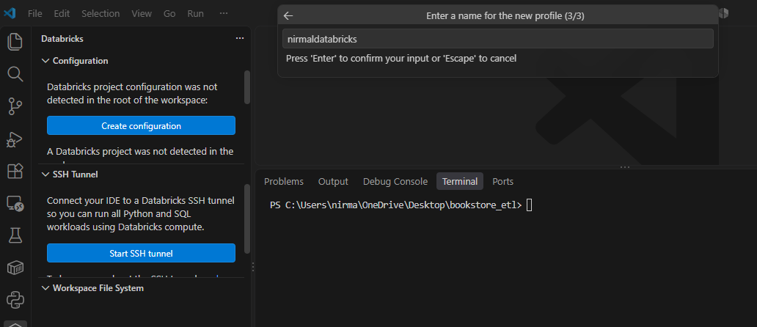
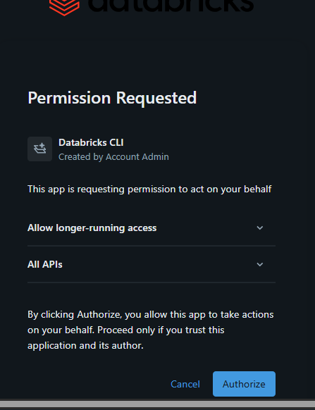
Step 6: Authorize
databricks bundle init
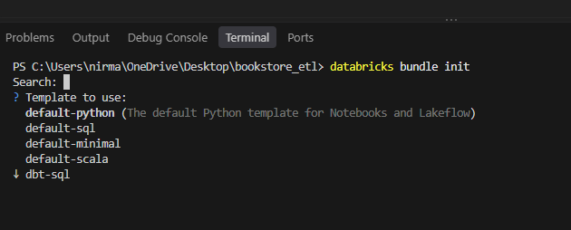
STEP 7: PYTHON
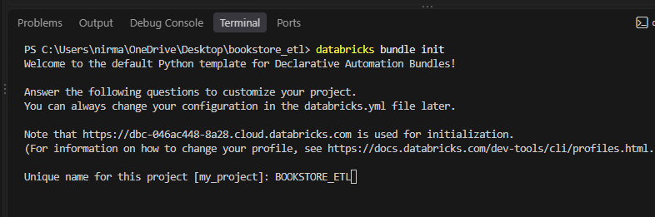
STEP 8: PROJECT NAME
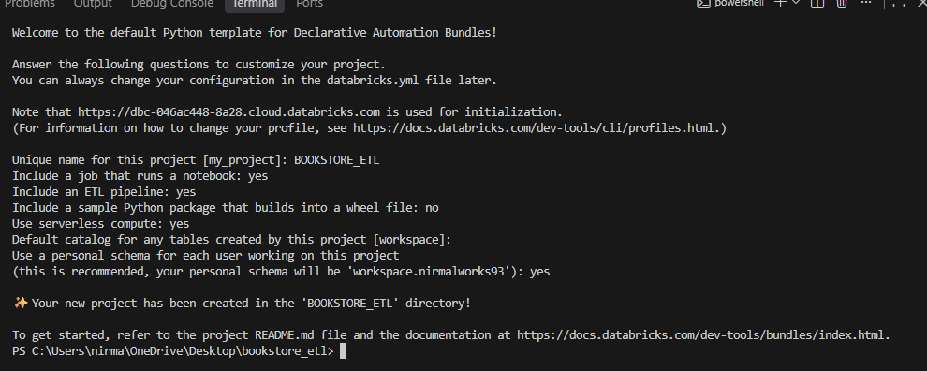
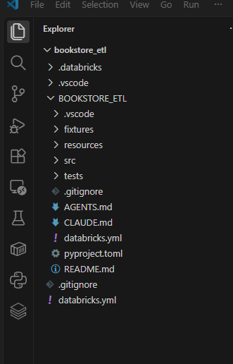
Step 9:
Go to inside bookstore etl
Step 10: delete the file in src and resource

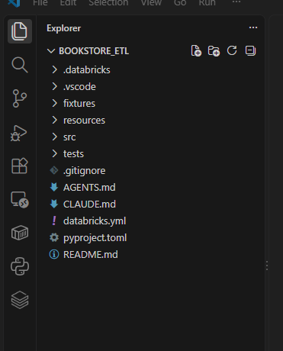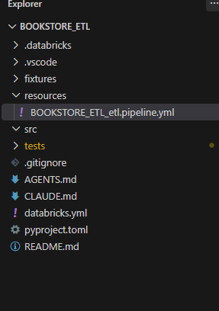
Step 11: download source file from databricks workspace
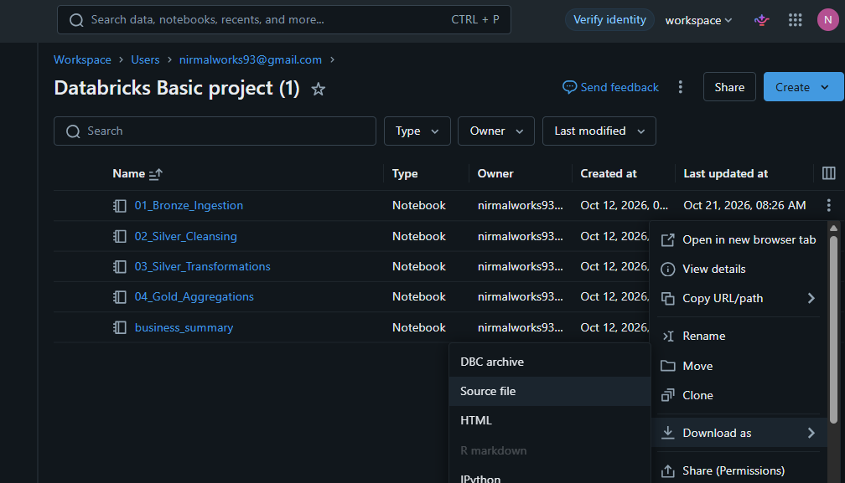
Step: paste the file in src
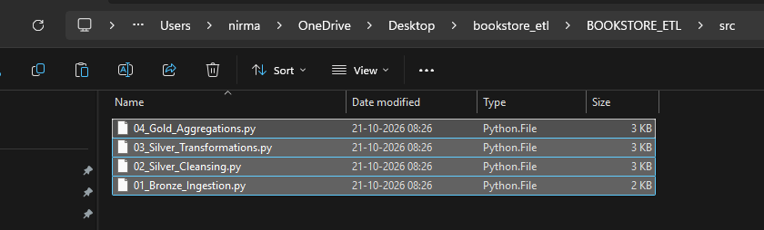
Step 6: add the respective file in bronzelayer
Step 7: copy the job yaml in resource and rename the ymal also

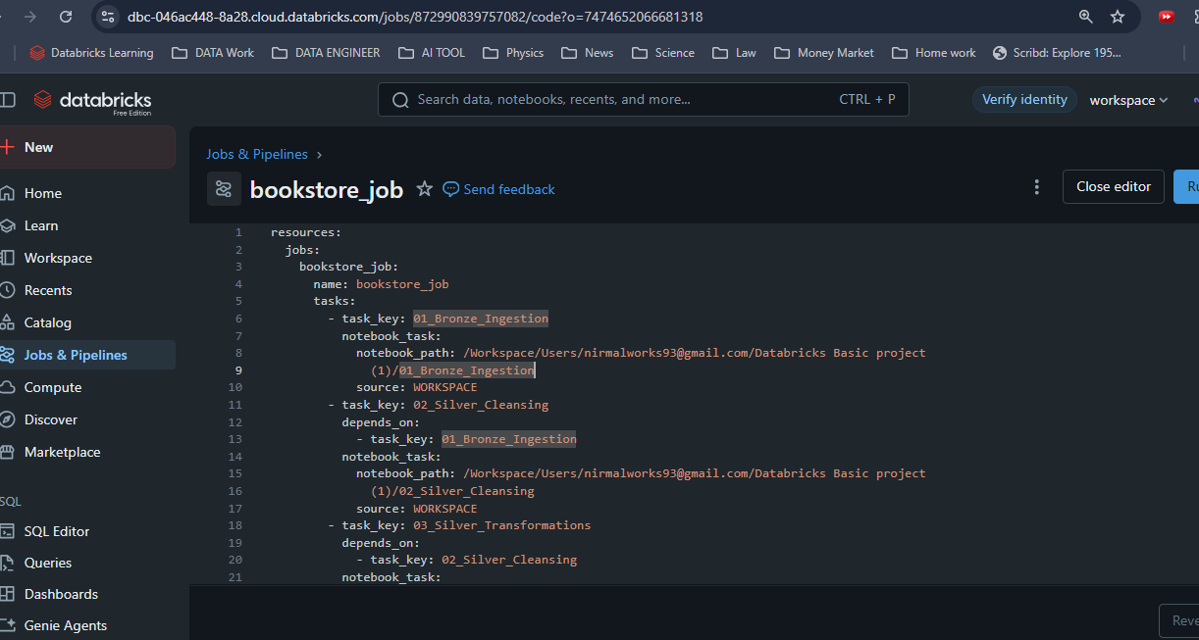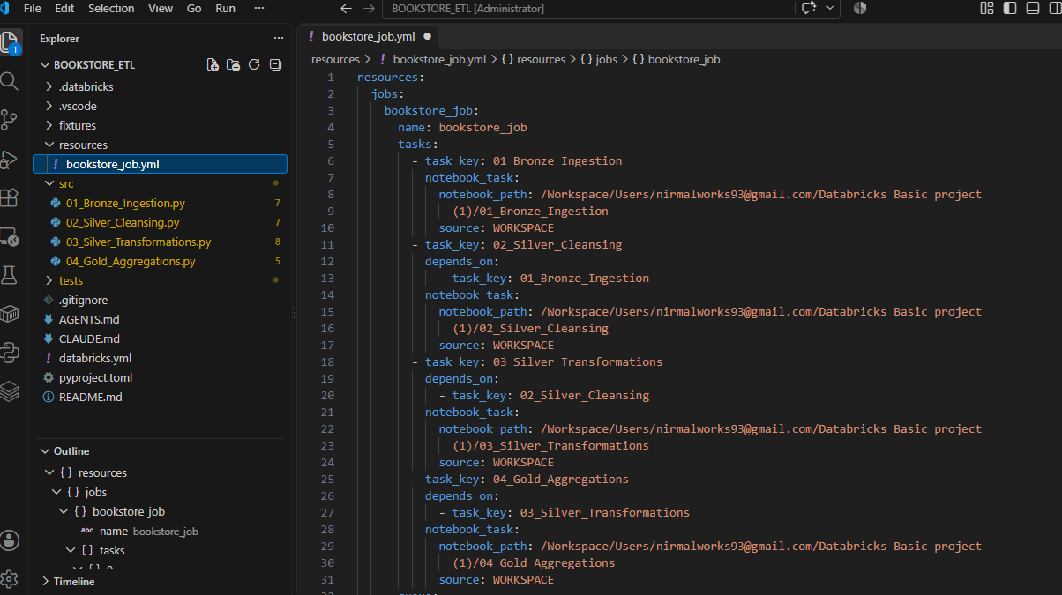
Modify the path
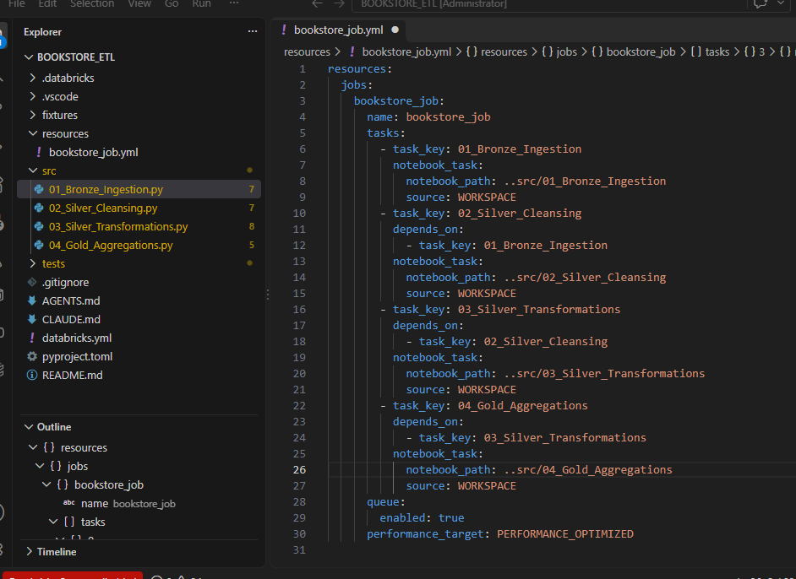
Change the catalog and schema
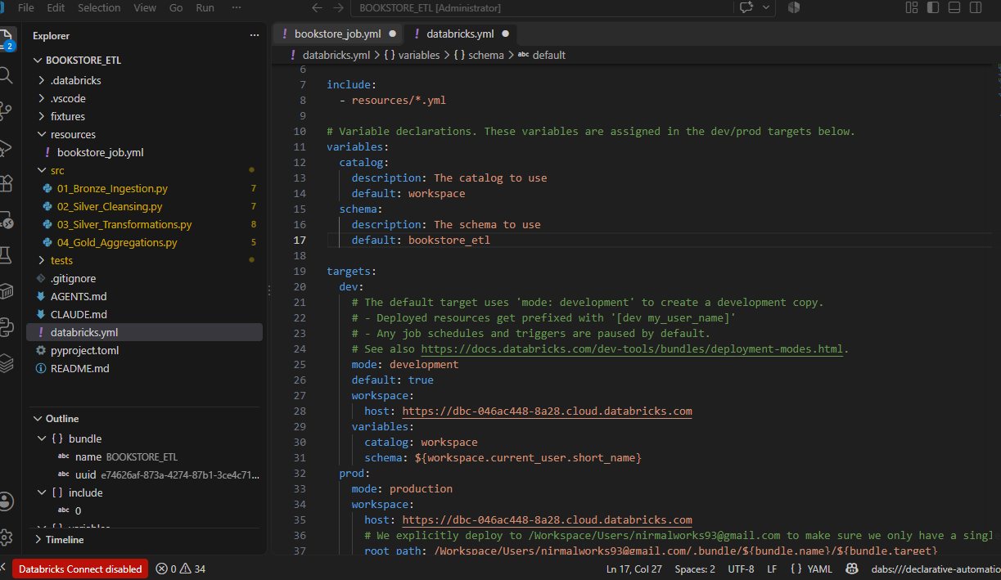

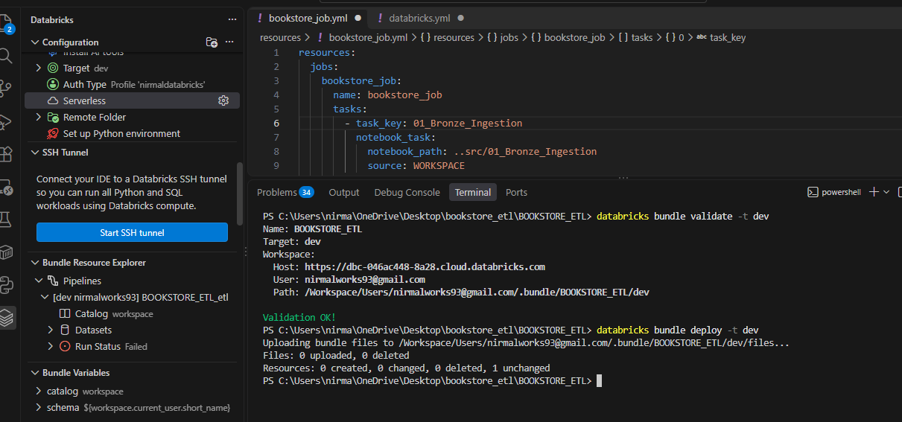
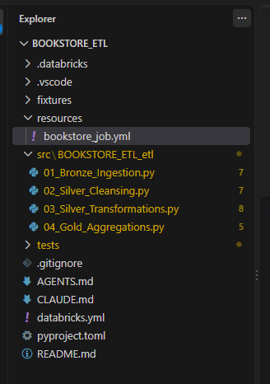
Bundle is deployed

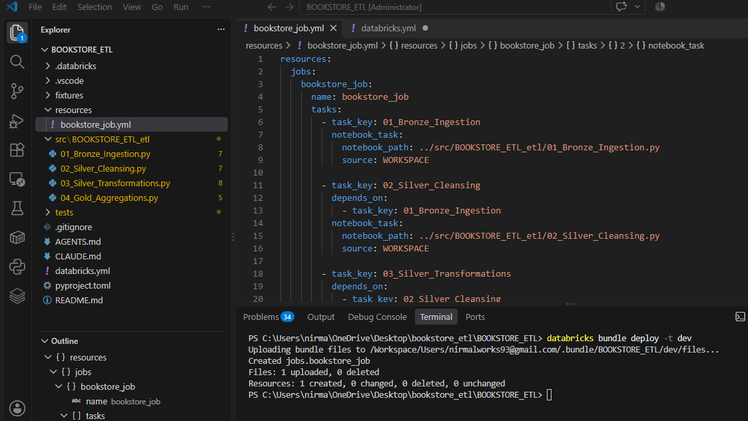

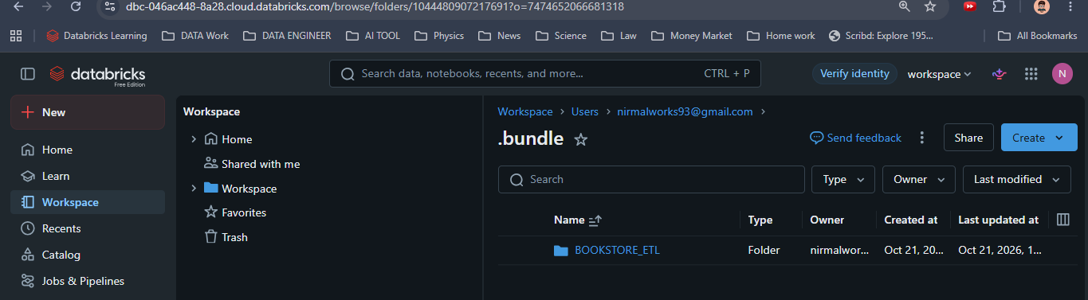
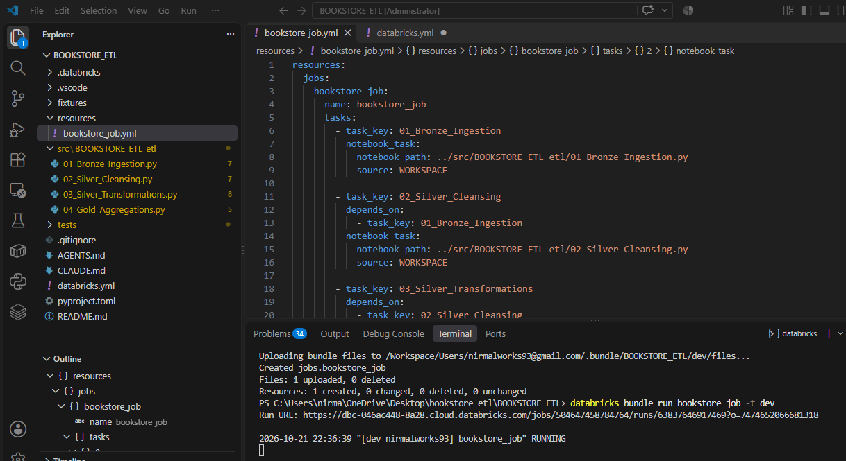

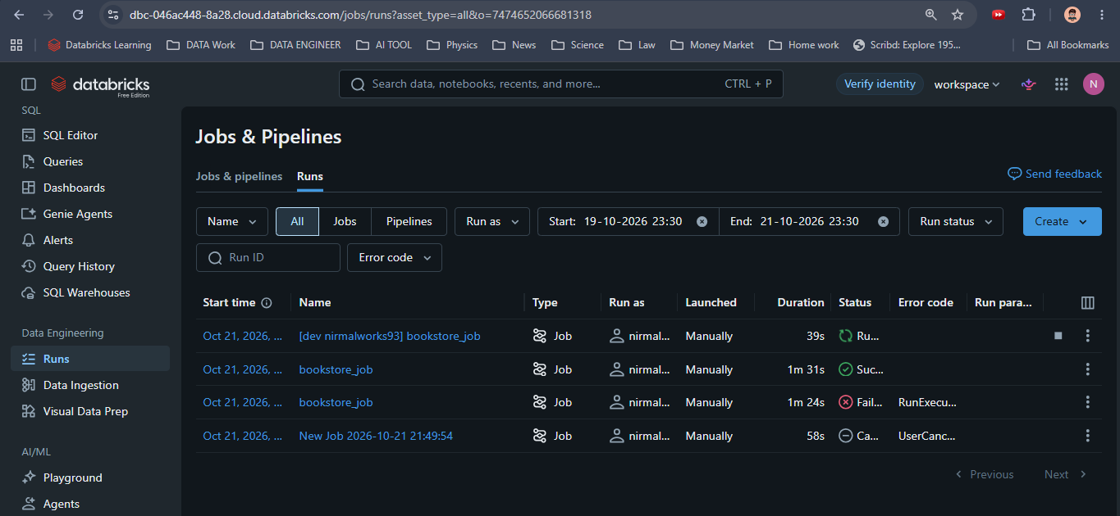
Job is start running
databricks bundle run bookstore_job -t dev
databricks bundle deploy -t dev
